Name: S.Mohammad kaif
Reg no: 192472278
Course Name: Design and Analysis of Algorithm
Course Code: CSA0652
Assessment: CO5-Assessment Tool 2

Report 2
Q55: Combination Generation with Sum Constraint Using Backtracking

Aim

The aim of this experiment is to generate all possible combinations of size k from a given set of numbers such that the sum of the selected elements equals a specified target value. The problem is solved using the Backtracking technique with pruning to improve efficiency by eliminating invalid combinations early.

Problem Description

Combination generation is a common combinatorial problem where a subset of elements is selected from a larger set. In this problem, only combinations that satisfy the following conditions are considered valid:

  - Exactly k elements must be selected.
  - The sum of selected elements must equal the target value.
  - Each element can be selected only once.
  - All valid combinations must be generated.

Since the number of possible combinations grows rapidly with the size of the set, Backtracking is used to systematically explore feasible solutions while pruning unnecessary branches.

Objectives

  - Generate all combinations of size k.
  - Ensure the sum of selected elements equals the target value.
  - Apply Backtracking for systematic exploration.
  - Use pruning techniques to reduce computation.
  - Display all valid combinations satisfying the constraints.

Algorithm

Step 1: Input : Read:

  - Set of numbers
  - Combination size k
  - Target sum

Step 2: Initialize

Create an empty list to store the current combination.

Step 3: Recursive Selection

Select elements one by one starting from the current position.

Step 4: Check Constraints

For every recursive call:

- Add the current element to the combination.
- Update the current sum.

Step 5: Pruning

If the current sum exceeds the target value:

- Stop exploring that branch.
- Return to the previous state.

Step 6: Valid Combination Check

If:

- Combination size = k
- Current sum = target Then:
- Store or print the combination.

Step 7: Backtracking

Remove the last selected element and continue exploring alternative choices.

Step 8: Output

Display all valid combinations.

Backtracking Strategy

The algorithm follows a depth-first search approach:

  - Select an element.
  - Recursively explore further selections.
  - If constraints are violated, backtrack.
  - Continue until all valid combinations are discovered.

Pruning Techniques Used

- 6.1 Sum-Based Pruning
If the current sum exceeds the target value:
Current Sum > Target
The branch is terminated immediately.

6.2 Combination Size Pruning
If the combination already contains k elements:
Length(Current Combination) = k
The algorithm checks validity and stops further expansion.

6.3 Index-Based Selection
Elements are selected only from subsequent positions to avoid duplicate combinations. These pruning methods significantly reduce unnecessary recursive calls.

Example Input
Set = {1, 2, 3, 4, 5}
k = 3
Target = 9

Execution

Possible combinations of size 3:

{1,2,3} = 6
{1,2,4} = 7
{1,2,5} = 8
{1,3,4} = 8
{1,3,5} = 9 ✓
{1,4,5} = 10
{2,3,4} = 9 ✓
{2,3,5} = 10

{2,4,5} = 11
{3,4,5} = 12

Output

[1, 3, 5]
[2, 3, 4]

Total Combinations = 2
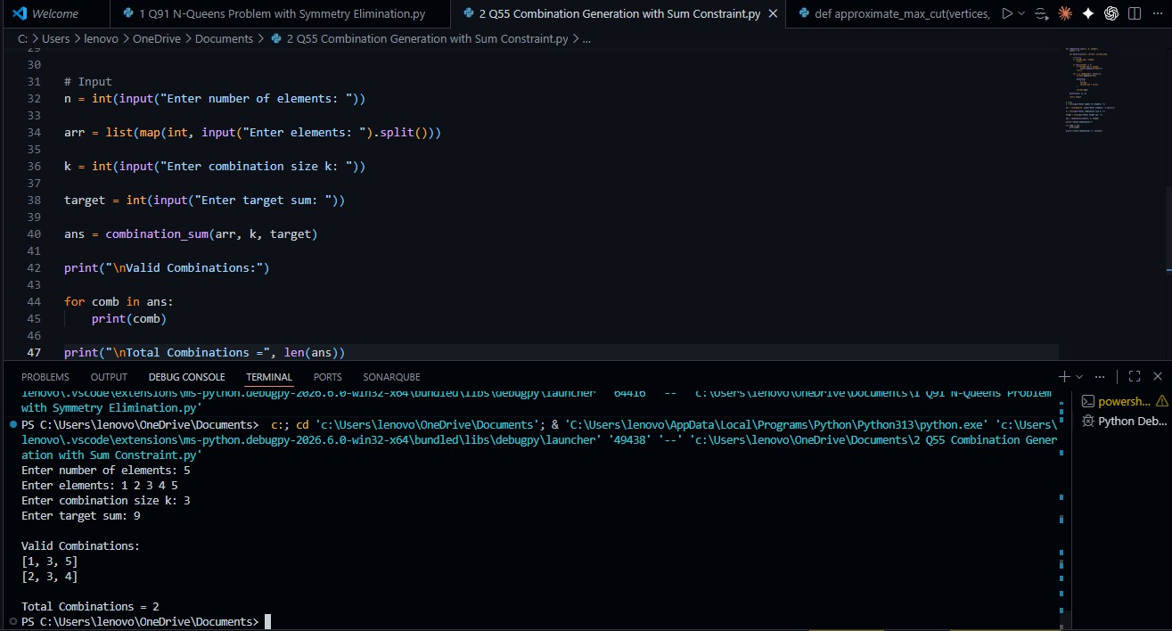

Correctness of the Algorithm

The algorithm is correct because:

  - Every possible combination is explored systematically.
  - No combination is repeated.
  - The recursive procedure considers all valid element selections.
  - Pruning removes only impossible branches.
  - A combination is accepted only when:
    - Exactly k elements are selected.

    - Their sum equals the target value.

Thus, all valid combinations are generated and no valid solution is missed.

Complexity Analysis Time Complexity
In the worst case, all combinations of size k must be explored: O(C(n, k))
where:

- n = number of elements
- k = combination size

The binomial coefficient represents the total number of possible combinations.

Space Complexity

O(k)

Space is required for:

- Recursive call stack
- Current combination storage

Advantages

  - Efficiently generates valid combinations.
  - Avoids duplicate combinations.
  - Uses pruning to reduce unnecessary computations.
  - Easy to implement and understand.
  - Suitable for combinatorial search problems.

Applications

  - Resource Allocation Problems
  - Team Formation and Selection
  - Subset Sum Problems
  - Scheduling Systems
  - Financial Portfolio Selection
  - Data Mining and Pattern Discovery
  - Artificial Intelligence Search Problems
  - Constraint Satisfaction Problems (CSP)

Result

The Combination Generation with Sum Constraint problem was successfully solved using the Backtracking technique. The algorithm efficiently generated all combinations of size k whose sum matched the target value. Pruning strategies eliminated infeasible branches early, reducing computational overhead and improving performance. The experiment demonstrates the effectiveness of Backtracking for solving constrained combinatorial optimization problems.

